DISCRIMINANT ANALYSIS (DA) OF GUANACO’S PELVIS
We used a Discriminant Analysis (DA) to test the sex of specimens of known sex by independent parameters (n = 26) (Figure 1). To this end, the first three PCs were used.
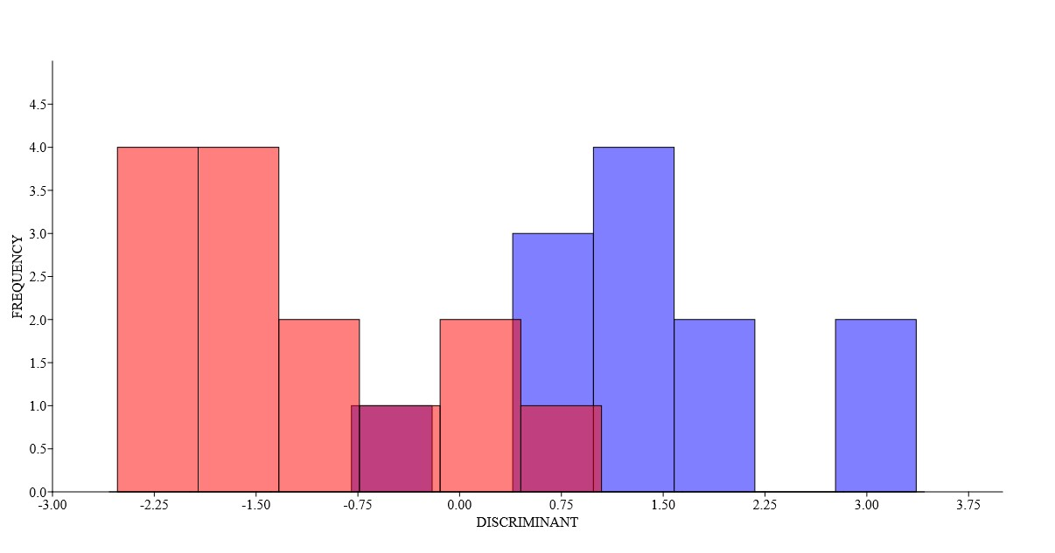
Figure 1. Discriminant analysis of guanacos of known sex by independent parameters. Red: males; Blue: female.

The discriminant function correctly classified 92.3% of this specimens into the correct male - female groups (Table 2).

Confusion matrix
 | MALE | FEMALE | TOTAL
MALE | 11 | 1 | 12
FEMALE | 1 | 13 | 14
TOTAL | 12 | 14 | 26
Table 2. Confussion matrix of guanacos of known sex by independent parameters

Cross-validation was used to estimate the accuracy of the discriminant function, obtaining a correct classification percentage of 88.5% (Table 3).

Confusion matrix
 | MALE | FEMALE | TOTAL
MALE | 11 | 1 | 12
FEMALE | 2 | 12 | 14
TOTAL | 13 | 13 | 26
Table 3. Confussion matrix (Jackknifed) of guanacos of known sex by independent parameters.
Classifiere
SPECIMEN | GIVEN GROUP | CLASIFICATION | JACKKNIFED
FCS.CC.117 | M | F | F
FCS.CC.12 | F | F | F
FCS.CC.14 | M | M | M
FCS.CC.149 | M | M | M
FCS.CC.15 | F | F | F
FCS.CC.47 | F | F | F
FCS.CC.5 | F | F | F
FCS.CC.50 | F | F | F
FCS.CC.65 | F | F | F
FCS.CC.70 | F | F | F
FCS.CC.99 | F | F | F
FCS.CC.100 | M | M | M
FCS.CC.108 | M | M | M
FCS.CC.111 | F | F | F
FCS.CC.118 | M | M | M
FCS.CC.120 | F | F | M
FCS.CC.121 | M | M | M
FCS.CC.125 | M | M | M
FCS.CC.132 | F | M | M
FCS.CC.150 | F | F | F
FCS.CC.24 | M | M | M
FCS.CC.30 | F | F | F
FCS.CC.31 | M | M | M
FCS.CC.62 | M | M | M
FCS.CC.63 | M | M | M
FCS.CC.72 | F | F | F
Table 4. Classifiere of guanacos of known sex by independent parameters.

Classifiere
SPECIMEN | GIVEN GROUP | CLASSIFIERE
FCS.CC.139 | D | F
FCS.CC.148 | D | M
FCS.CC.158 | D | M
FCS.CC.16 | D | F
FCS.CC.17 | D | M
FCS.CC.36 | D | M
FCS.CC.42 | D | M
FCS.CC.61 | D | M
FCS.CC.64 | D | F
FCS.CC.66 | D | M
FCS.CC.105 | D | M
FCS.CC.119 | D | M
FCS.CC.133 | D | M
FCS.CC.55 | D | M
FCS.CC.73 | D | M
FCS.CC.82 | D | M
FCS.CC.85 | D | M
FCS.CC.86 | D | M
FCS.CC.91 | D | M
Aislada 1 | D | F
Aislada 4 | D | F
Aislada 5 | D | F
FCS.CC.101 | D | M
Aislada 6 | D | F
Table 5. Classifiere of guanacos of unknown sex.

