Distribution of epigaeic ants (Hymenoptera: Formicidae) across the transition between the Subantarctic and Patagonian subregions of the Andean region

**Metadata**

Variables in “MBD_community.xls”:

*CatalogNumber*: The catalog number of the samples

Example: **LT2S10M6H1**.

"**LT**" and a **number**: Longitudinal Transect from 1 (north) to 5 (south). See Figure 1 in this metadata

"**S**" and a **number**: number of Site in each transect from 1 (west) to n (east). See Figure 1 in this metadata.

**M6**: The first letter of the collection month and the last number of the collection year, M6 collected in March 2006 (other possibilities are N4 November 2004, M5 March 2005, J5 January 2005)

“**H**” and a **number**: The letter “H” is the acronym of “hormiga” (ant in Spanish). The number correspond to the sample number for each transect, site and month. The letter “H” is omitted in the printed labels, but it is present in digital files because it makes it easier to read the last two numbers that without that letter "H" would be contiguous

Example: LT2S10M6H1 = longitudinal transect number two, site number in the transect = 10, collected in March 2006, ants sample 1

*Disposition*: The final disposition of the specimens

BACRU: biological collection of arthropods (BACRU) in the University of Comahue, Centro Regional Universitario (CRUB)

ML: Kusnezov’s collection (Instituto-Fundación Miguel Lillo, Tucuman, Argentina)

NA: Not available

Figure 1. Location of 50 sampling sites within the (a) forests (black squares), (b) shrublands (circles) and (c) steppes (black triangles). The number of transect is indicated.

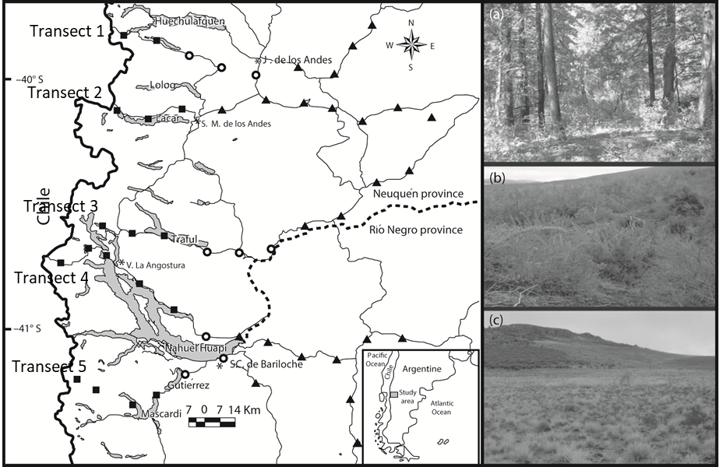

Figure 2. Location of 50 sampling sites. The number of transect and number of sites within each transect is indicated

