A new Toxodontia (Mammalia, Panperissodactyla, Notoungulata) from the Oligocene of Patagonia, Argentina, and systematic considerations about the paraphyletic ‘Notohippidae’

Gastón Martínez^{a,b}*, María T. Dozo^{a,c}, Javier N. Gelfo^{a,d}, Martín R. Ciancio^{a,d,e} and Rolando González-José^{a,f}

ªConsejo Nacional de Investigaciones Científicas y Técnicas, Godoy Cruz 2290, CABA, C1425FQB, Argentina; ^{b}Museo de Paleontología, Facultad de Ciencias Exactas, Físicas y Naturales, Universidad Nacional de Córdoba, Vélez Sarsfield 249, Córdoba, X5000JJC, Argentina; ^{c}Instituto Patagónico de Geología y Paleontología, CCT CONICET-CENPAT, Brown 2915, Puerto Madryn, U9120ACD, Argentina; ^{d}División Paleontología Vertebrados, Museo de La Plata, Facultad de Ciencias Naturales y Museo, Universidad Nacional de La Plata, Paseo del Bosque s/n, La Plata, B1900FWA, Argentina; ^{e}Laboratorio de Morfología Evolutiva y Desarrollo (MORPHOS), Museo de La Plata, FCNyM, UNLP; ^{f}Instituto Patagónico de Ciencias Sociales y Humanas, CCT CONICET-CENPAT, Brown 2915, Puerto Madryn, U9120ACD, Argentina;

(Received 9 July 2020; accepted 18 December 2020)

* Corresponding author. Email: gmartinez@unc.edu.ar

(Supplemental material 4)
IterPCR results

The following reduced consensus is obtained after prunning the most unstable taxa:
================================================================================

Note: for consensus calculation, trees will be
temporarily collapsed (when min. branch length = 0)

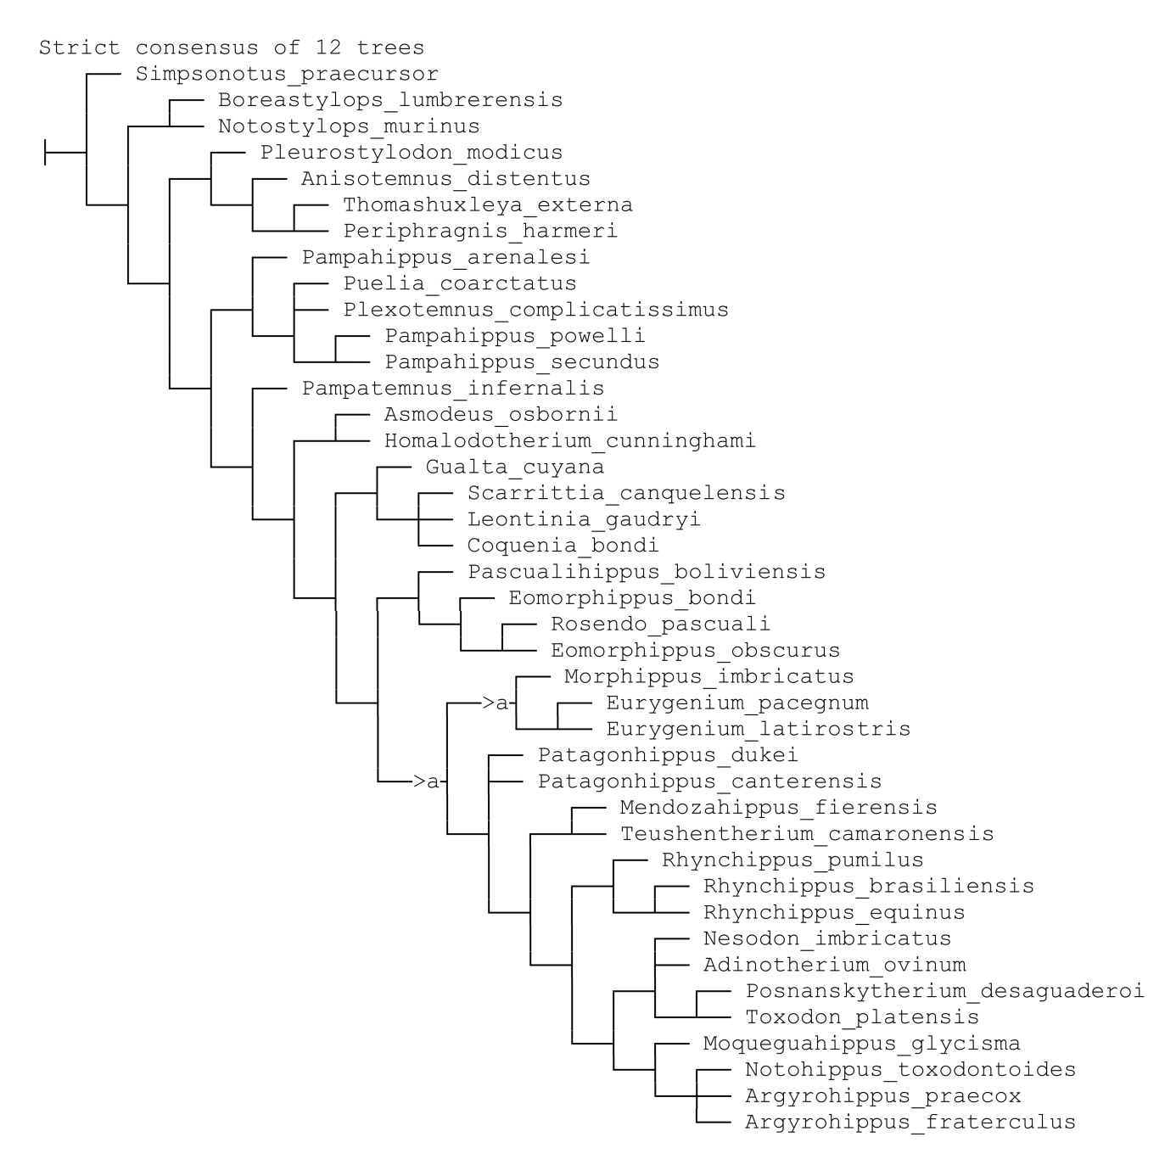

Legends:
a: Eomorphippus_neilopdykei (22)

----------------------------------------------------------------------------
The following taxa are unstable and collapse nodes in the strict consensus:
----------------------------------------------------------------------------
Eomorphippus_neilopdykei
Scoring the following characters may help to resolve its position:
1 4 9 18 24 25 27 30 41 45 53 69 75 76 80 83 84 87 88
================================================================================
EVALUATING CHARACTERS INVOLVED IN ALTERNATIVE POSITIONS OF UNSTABLE TAXA TOOK 0 SECONDS
================================================================================

